INTRODUCTION

The project is on Cricket Record Keeping. At first the software inserts the player code, player name and their respective runs in matches like test match, twenty twenty and one day international. As soon as someone enters the player code, details of the particular player can be viewed .

As another option occurs like modifying, in this option as the player plays its further matches we are supposed to modify his all matches runs according to his recent played matches .

As his retirement time comes or any other situations like health performance we are supposed to delete the player record by entering his player code.

In huge database of records it is difficult to search for one player in the file, for that reason we have an option called search in order to search for a particular player records by entering his player code. In the existing records if that player does not exist by the given player code then it displays “ player code does not exist by this player code”.

The main advantage of this project is that it converts all the manual work which is time consuming and error porn to fully automated system which helps in eliminating paper work , less time consuming .It also speeds up various process like addition of new players to the list, deletion of players from the list modification of details of the players and calculation of total runs played by players.

Overall this software helps us to keep the records of various player with the unique player code and helps us to keep the tract of the recent played matches and go on modifying the runs of those matches which they have played by adding the scored runs to the existing runs which are stored at the backend file system .

In this language C++ language is used to maintain all the data . It provides many features like file handling, data can be easily maintained and many features that are required while doing the project.

LITERATURE SURVEY

Object oriented programming is the most recent concept among programming paradigms and still means different things to different people. It is therefore important to have a working definition of object oriented programming before we proceed further. We define “object”-oriented programming as an approach that provides a way of modularizing programs b creating partitions memory area for both data and functions that can be used as templates for creating copies of such modules on demand.

There are a few principle concepts that form the foundation of object-oriented programming-

Object

This is the basic run time entities in an object oriented system. They may represent an real world person, place, a table of data or any item. Object takes up space in memory have an associated link. That is both data and function that operate on data are bundled as a unit called as object.

Class

The entire set of data and code of an object can be made user-defined data type with the help of an class. each object is associated with the data of type class with which they are created. A class is thus a collection of object of similar type. Classes are user defined data types and behave like the built in types of programming language.

Abstraction

Abstraction refers o the act of representing essential features without including the background details or explanations. Since he classes used the concept of data abstraction, they are known as abstract data types. The attributes are sometimes called data members because they hold information. The functions that operates on this data are sometimes called methods or member functions

Encapsulation

The wrapping up of data and function into a single unit called class is called encapsulation. Data encapsulation is the most striking feature of a class. Insulating the data from direct access by the user is called data hiding. Here no memory is allocated for the class.

Inheritance

Inheritance is the process by which objects of one class acquire the properties of objects of another class. It supports the concept of hierarchical classification. In oop, the concept of inheritance provides the idea of reusability. This means that we can add additional features to an existing class without modifying it .

Polymorphism

It is another important oop concept. Polymorphism, a greek term which means ability to take more than one form. An operation may exhibit different behaviors in different instance. The behavior depends upon the types of data used in the operation. The process of making an operator to exhibit different behaviors in different instances is known as operator overloading.

Correlating theoretical concept to practical implementation

1. Static Variables : In our project we had used static variable for declaring constant variable to generated the player code serially. Ex: For static constant value is 3 etc.

2. Class : We had used a class in our project, which includes all the all the data members and member functions used in our project. We had used seven data members and fourteen member functions in our project to implement “Cricket Record Keeping”.

3. Friend Function : We had declared an overloaded function as friend to the class known as operator overloading using friend function to overload extraction(<<) operator.

4. Files :We had used two text files in our project one to store the details of the player record that are created by the organizer record.dat and another text file which is used to store the details of the player record that were deleted by the organizer , this is useful for temporary storage i.e temp.dat and can also be used for future reference and also data deletion will be more safely done.

We had used tellg() during modification of the player record. It moves the get pointer from the current to the required position where we need to modify the player record.

We had used seekg() during deletion of the player record . It moves the get pointer to the beginning of the temporary file and add the details of the product to it.

The modes of file we used are:

in -> which indicates input mode, it opens the text file used for reading the player record from file.

out -> which indicates output mode, it opens the text file used for writing the player record into the file.

app-> which indicates append mode, it opens the text file used for adding the details of the player record one after the another at end.

5. This pointer: To obtain the total runs of a particular player we have used this pointer to return implied object i.e total runs of the player after calculating carrier runs.

6. Header files : We had used the following header files in our project –

<iostream> is used for defining the c++ input and output streams.

<fstream> is used for input and output stream for the text files used in our project.

FLOW DIAGRAR

**MAIN PAGE**

INSERT RECORD

DISPLAY RECORD

EXIT

SEARCH RECORD

MODIFY RECORD

PLAYER CODE

HIGHEST RUNS

PLAYER NAME

DELETE PREVIOUS ENTERED RECORD

1.TEST MATCH RUNS

2.ONE DAY INTERNATIONAL

3. TWENTY TWENTY

RESULTS

RESULTS

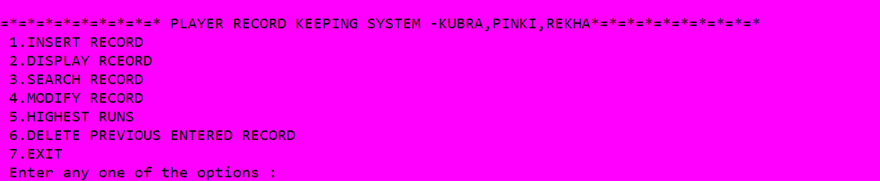

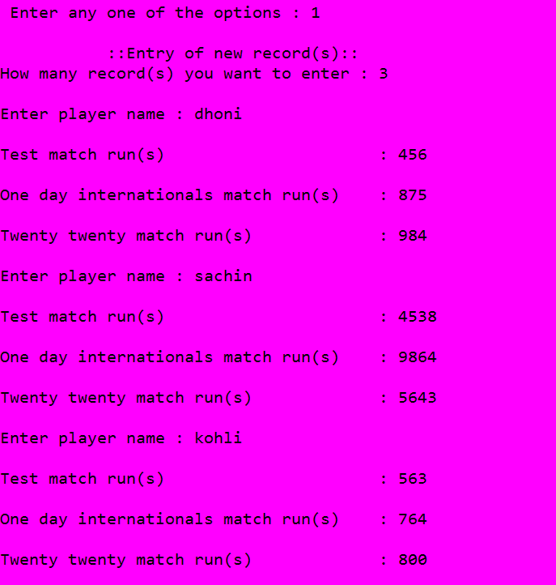

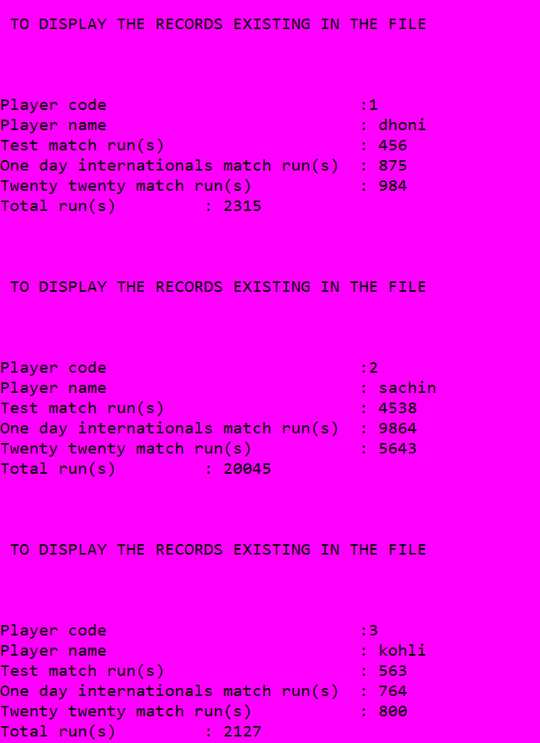

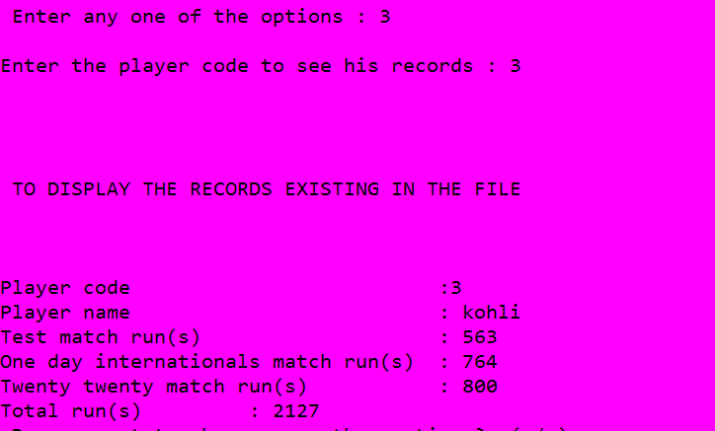

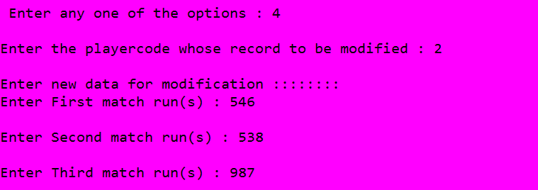



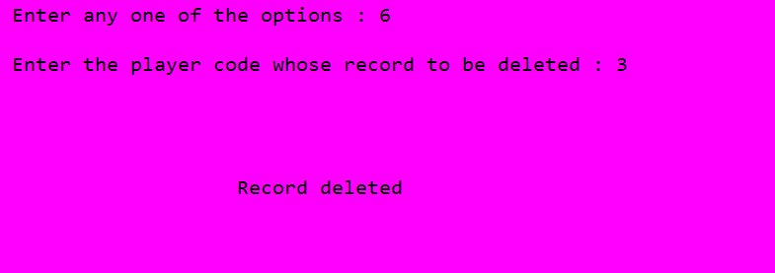



CONCLUSION

We have tried to develop system that can be great help for organizer of the cricket for keeping the record of the player. Despite of all our efforts here are some bugs in the system, which are still to be removed. This is possible by testing being done in the system. We have included the known features in the project in the best possible way out of it. And also left it open so we an future enhancement to be done by the user it can be done easily. In the end we wish to say that computers should put to such use where not only there capabilities are fully exploited but, what is more important, serve the society by raising the standard of the living of people, thereby making the world better place to live and work in.

BIBLIOGRAPHY

1.The complete Reference C++,Fourth Edition by Herbert Scheldt.

2..web links:

[www.codeitaway.wordpress.com](http://www.codeitaway.wordpress.com)

[www.kg.rybnik.pl](http://www.kg.rybnik.pl)

PLAGIARISM CHECK FOR REPORT

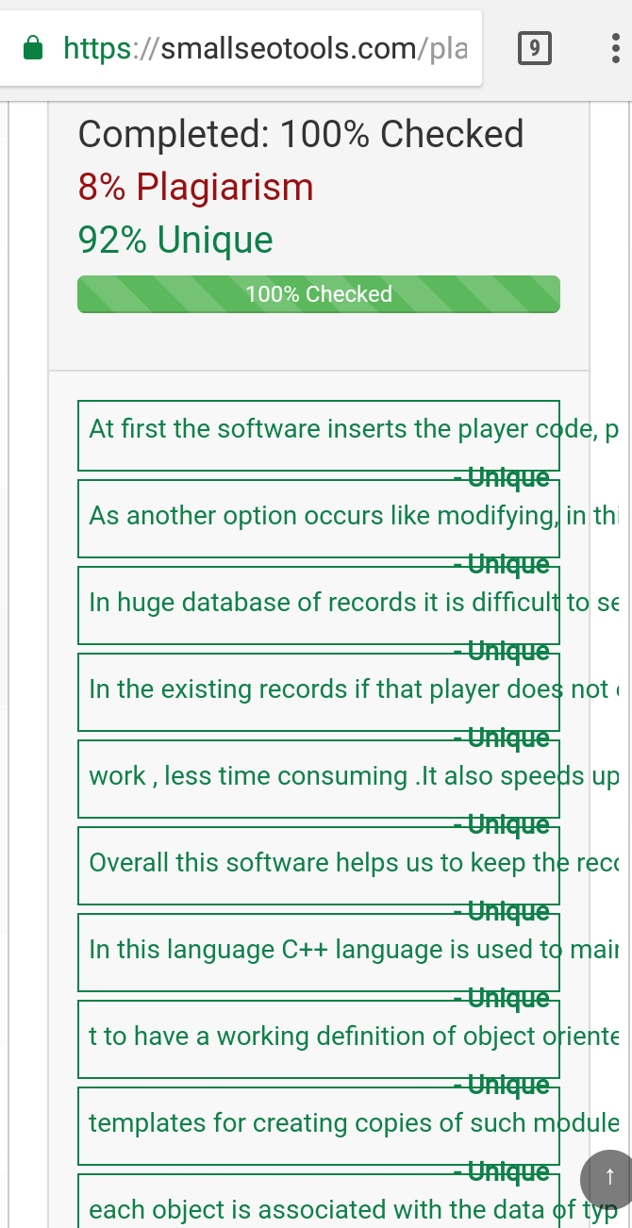

PLAGIARISM CHECK FOR CODING

